Software Engineering Group Project

COMP2002 / G52GRP: Interim Report

Project information:

Project title: UNiDAYS RECAPPED

Project sponsor: UNiDAYS

Academic supervisor: Julie Greensmith

Industry Sponsor: (if applicable)

Industry Supervisor(s): Alex Johnson, Joshua Richardson, Paul Tosseano, Greg Tudor

Team information:

Team number: 20
First Name | Last Name | Student ID | Username
Lewis | Evans | 20583571 | psyle2
Jakub | Sobolewski | 20521795 | psyjs34
Luke | Cunningham | 20549568 | psylc12
Joshua | Gaynor | 20549366 | psyjg22
Adrian | Nyathi | 20567917 | psyan13
Harry | Scott | 20548476 | psyhs16
Zayn | Awan | 20564764 | psyza6
Perfecto | Lacuesta | 20586012 | psypl4

Resource Links
Resource | Link
Repository (dev branch) | https://projects.cs.nott.ac.uk/comp2002/2024-2025/team20_project/-/tree/dev?ref_type=heads
Repository (Docs folder) | https://projects.cs.nott.ac.uk/comp2002/2024-2025/team20_project/-/tree/dev/docs?ref_type=heads
Trello board | https://trello.com/b/I7zMREak/team-20-trello-board

Table of Contents
Resource Links 1
Table of Contents 2
1.0 Project Background & Understanding 3
1.1 Project Brief 3
1.2 Additional Interpretations/Innovations 3
1.3 Contextual Understanding 3
2.0 Requirements & Critical Analysis 4
The user stories helped seamlessly form issues/tickets when it came to the implementation stage. 4
Analysis of Tools 5
Frontend Research 5
Database Research 5
User Surveys 6
3.0 Initial Software Implementation & Testing 6
Front End Implementation 6
Pipeline 8
Database 8
Fields 8
Implementation 9
Use of version control 10
Evidence of testing 12
4.0 Project Management and Progress 13
4.1 Project Management Plan 13
4.2 Documentation of Sprints and Meetings 13
4.3 Use of Project Management Tools 14
4.4 Use of team skills and attitude 14
5.0 Preliminary Reflection 14
5.1 Tools, techniques, methods, technical difficulties,testing 14
5.2 Current progress and mitigation 14
5.3 LSEPI 15
5.4 Team Member Contribution 16
5.5 Forward plan to address concern identified 16
6.0 Conclusion & Summary 16

1.0 Project Background & Understanding

Project Brief
The Recapped project aims to provide students with a yearly summary of their interactions with the UNiDAYS marketplace. With a focus on virality, each Recapped aims to be exciting and playful, as well as personalized and unique. To deliver this, much emphasis is placed on UI/UX to create a website that is both engaging and accessible to all device types. Other student discount platforms such as Student Beans provide metrics, but they are not personalised and do not provide yearly user-friendly summaries. Our Recapped will innovate to engage students in a new and exciting way.

Additional Interpretations/Innovations
Our initial interpretation of the brief was that we would provide different views that students could swipe or scroll through. These views would show a student’s metrics over the past year including (1) savings and discounts, (2) shopping habits, and (3) time-based metrics.
With virality and engagement in mind, we suggested gamifying the recapped. For the data-driven views, we wanted to provide community metrics for students to compare themselves against. For example ‘You were in the top 10% of savers’. In addition, we theorised that each view could have a fun fact, such as ‘You saved enough this year to pay for 5 free coffees!’. At the end of the Recapped, we thought that it could summarize key metrics into a shareable page. This page would contain buttons for students to share their summaries to social media, further enhancing engagement with the software.
UNiDAYS acts as an intermediary between companies and students. With this in mind, we came up with the additional idea of extending the project to create a Recapped experience for companies. This Recapped would allow companies to view their customer metrics akin to students viewing their shopping/savings metrics. This would allow them to make data-driven decisions about how customers interact with their products. After consulting UNiDAYS it was decided that, although a good idea, the focus should be on the student Recapped first before exploring other domains.

Contextual Understanding
Other personalised reviews like Spotify Wrapped transform user data into shareable experiences that are both deeply personal and inherently social. Inspired by Wrapped, our web application will transform raw data into an engaging, informative, and potentially motivational annual review by leveraging data analytics and user-centric design principles. This will not only provide value to students but can potentially also be used as a marketing tool for UNiDAYS.

2.0 Requirements & Critical Analysis
Before we began the implementation of our project, we performed a requirements analysis to help visualise the software and its potential use cases. We created a Use Case Diagram and a set of User Stories.
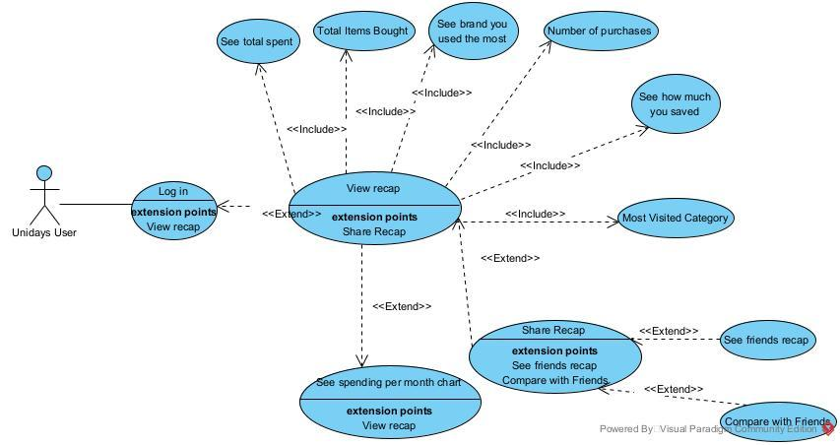
The Use Case Diagram provided an easy opportunity for feedback from the industry supervisors. When we showed them, they approved and indicated that it was a good starting point for when implementation began. This feedback also affirmed that our team and the supervisors were on the same page regarding the direction of the project.

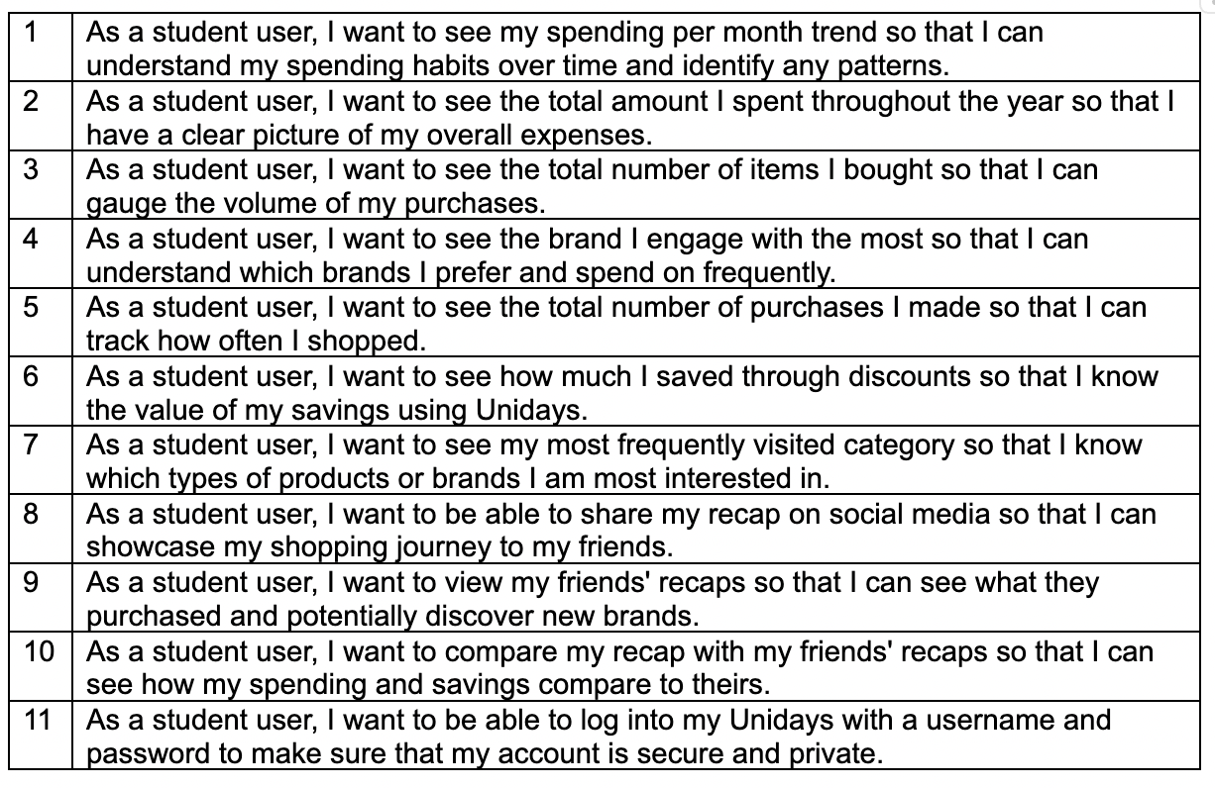

The user stories helped seamlessly form issues/tickets when it came to the implementation stage.

Analysis of Tools

Frontend Research
We have researched multiple technologies in order to implement the frontend development of our project. Although none of our team members have experience with React or TypeScript, based on recommendations from our industry supervisors, we decided to explore them as an option and eventually chose them. We chose TypeScript instead of normal JavaScript for our project due to its use of explicit types, which enhances code readability and improves team collaboration by making the code more understandable. Furthermore,TypeScript helps prevent type-related errors at run time, improving overall code reliability.
Through our research, we discovered React’s focus on reusable components and found that its learning curve was not too steep, especially since it is a JavaScript library and we have prior experience with JavaScript. This led us to select React and TypeScript, along with HTML and CSS, as our main languages and tools for developing the front end of our project. We also chose to use Vercel for deployment as it is simple to use, has a free tier, and integrates well with React and Next.js libraries.
Although not part of proof of concept, we plan to make use of Three.js for 3d data visualisations and the GPT-3 model OpenAI API for the Recapped fun facts.

Database Research
We did research on several databases as a service to identify which one is most appropriate for our secure storage and presentation of user data. We then reviewed each service in terms of security, scalability, and suitability for frontend data presentation.
Our go-to option for our database was Supabase since we have all previously used it in the first year for our databases and interfaces module. However, before we started our scrum, Joshua and Alex from UNiDAYS suggested that we research other databases that may be more suitable for Recapped.
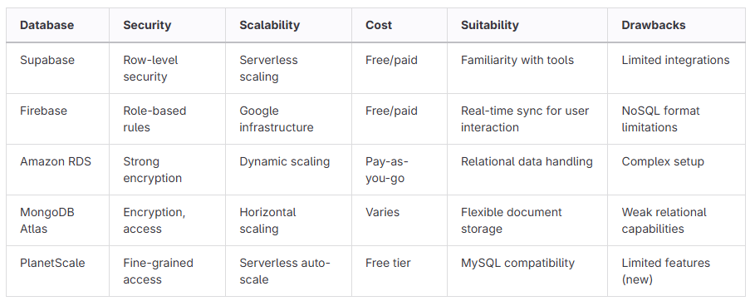
After researching numerous options for database hosting and backend management we decided Supabase was still the best option. This was justified as supabase offers Authentication and database services which we deemed necessary. It also has an effective API for us to fetch data with and is free to use.

User Surveys
We demonstrated our initial frontend designs and implementations to students who both do and don’t study computer science. Through a Microsoft form we were able to anonymously collect information on how they found the designs and what they thought of the current state of the product.
We asked the participants a series of questions that covered the usability and design appeal of our initial Recapped design and implementation. The results of the survey were mixed. The general theme was that the product, while intuitive, left a bit to be desired in terms of design. We addressed these issues in the revised implementation of our Recapped and Login page (see frontend implementation below).

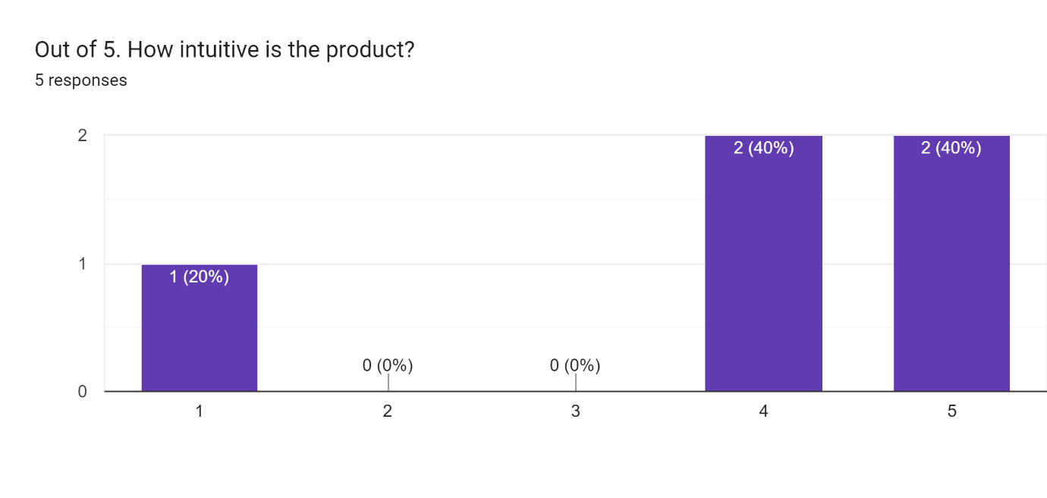 | 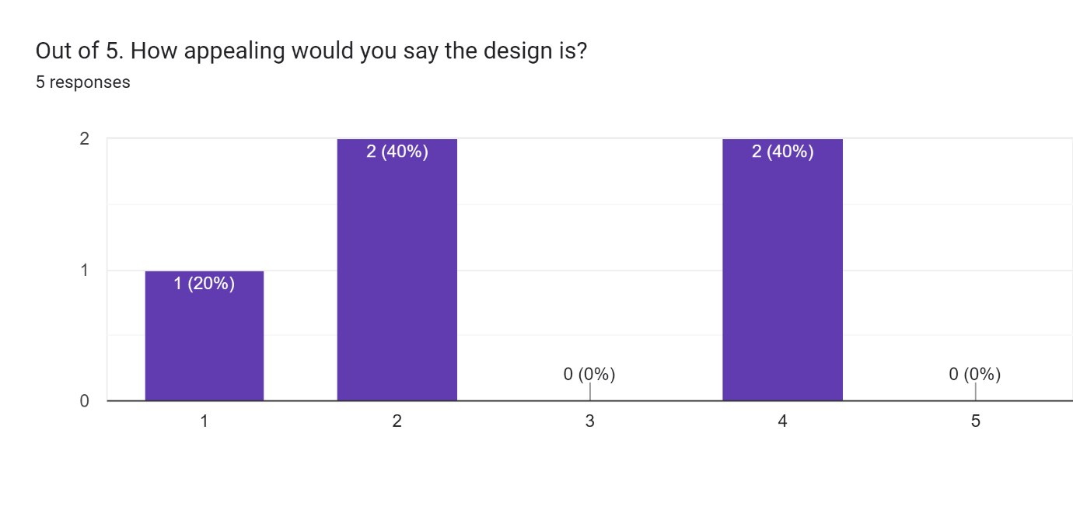

3.0 Initial Software Implementation & Testing

Front End Implementation

Design research
Our team decided to vote between Lexend, Gabarito and Afacad Flux as our main font for the project. The one that we chose was Gabarito as it was stylish and already similar to the font that UNiDAYS uses on their website. We also chose the four main colours (seen below) as they are prominent on the UNiDAYS website and we wanted the project to blend seamlessly with UNiDAYS existing brand image.

Fonts and Colour
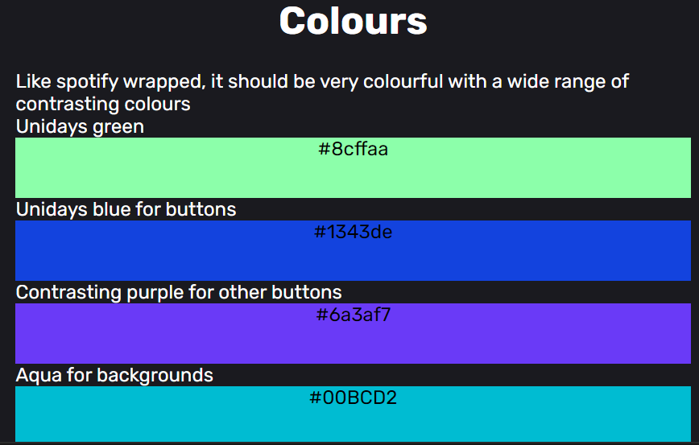 | 

Figma Designs
We created some mock-up designs on figma for our frontend to establish our ideas and present them to the industry supervisors. When shown the designs, the supervisors were impressed by the professional nature and indicated that they would be a good starting point to begin initial development of the minimum viable product.

Login and Recapped page Designs
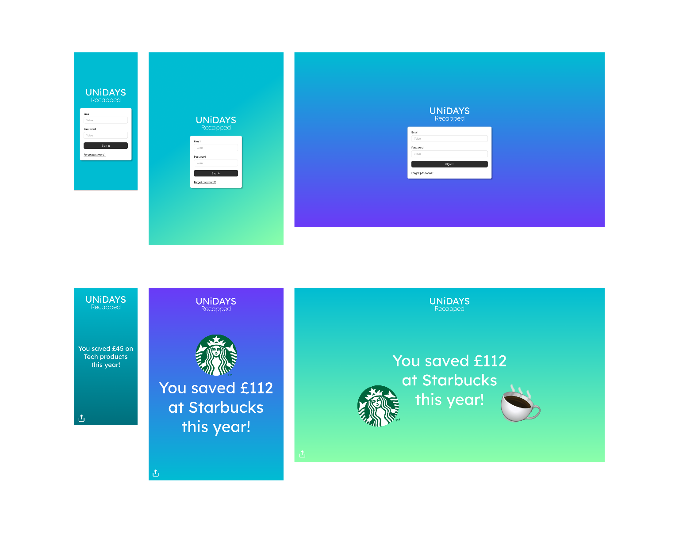

Login and Recapped page Implementation
Initial login page | Revised implementation
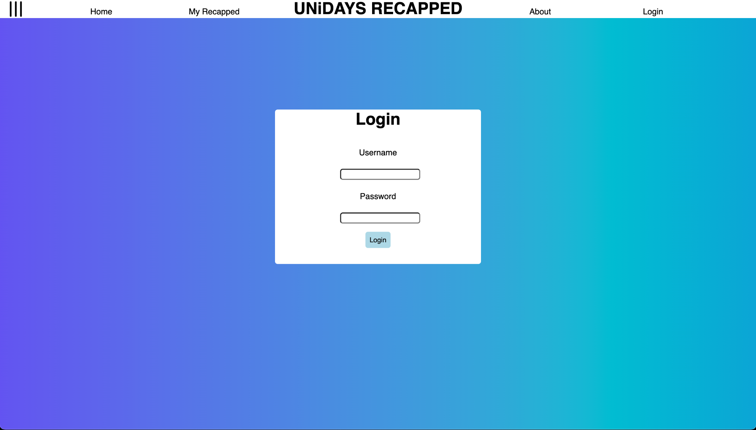 | 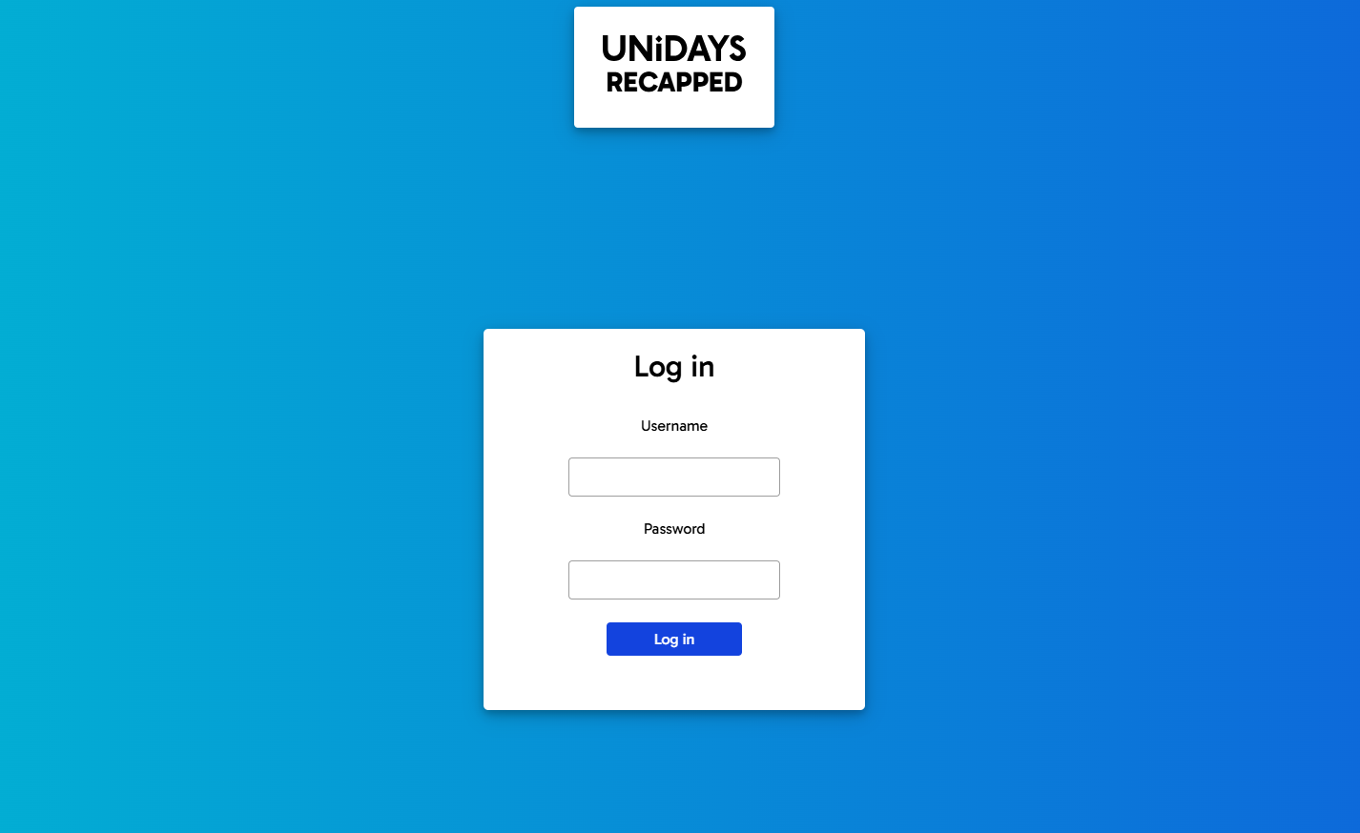

Initial Recapped page | Revised Implementation
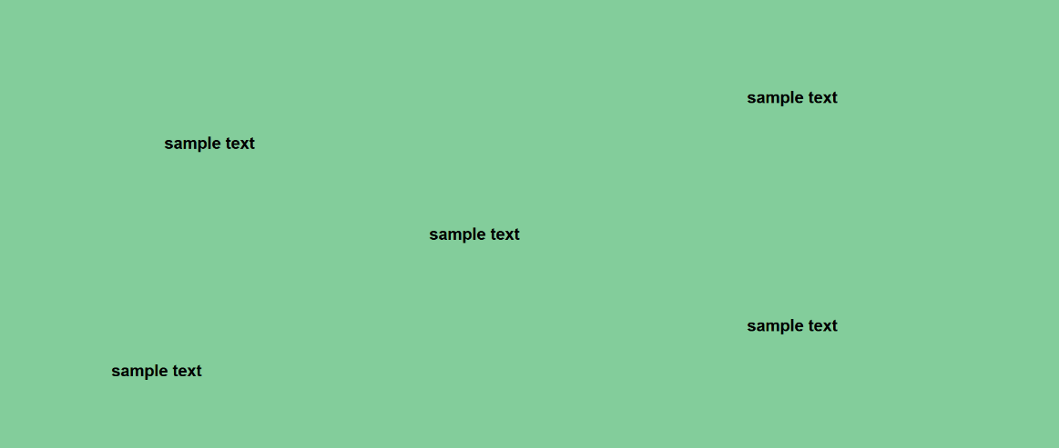 | 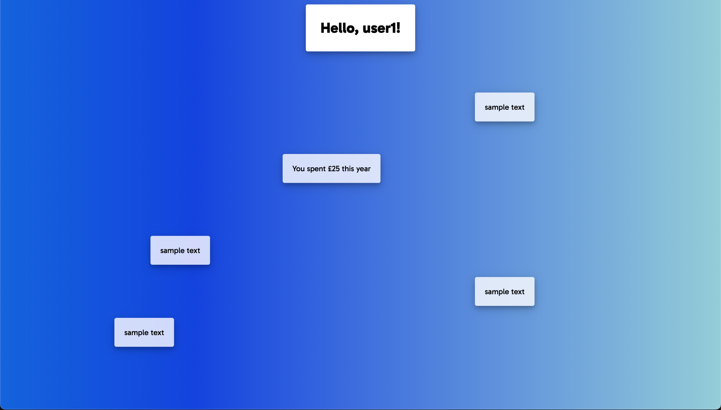

Pipeline
As determined in the early stages of the project, and after meeting with our industry supervisors, it was clear that implementation of continuous deployment would be beneficial. Connecting our git to Vercel was challenging, because the Gitlab instance hosted by the university is private. We implemented a pipeline that deploys to Vercel through a runner that is hosted on one of our machines using Docker. This ensures that whenever a merge is made to the dev or main branch, the new deployment is uploaded to Vercel to be hosted on a domain for the team to access and test. This will also be useful for demonstrations to supervisors and the final demo day. It also allows us to see how the website responds to user traffic.
In future we plan to set up automated tests using the pipeline to ensure deployed code is correct.

Database
The database design has been created in Visual Paradigm, with the necessary fields to meet the MVP, including userID, partnerID, and transactionAmount.
To meet normalisation standards, a fourth field, transactionID, was added. All the required fields are not unique and could therefore not be used as a primary key, and a composite key was also not appropriate since it is possible to have two entries where all 3 fields, the user, partner, and amount are all identical. The transactionID field acts as a identifier for each transaction, it is not nullable, and always unique.
To meet the MVP requirements, the userID and the partnerID can be regular not nullable fields, if the project progresses beyond the MVP stage, these will be foreign key relations to other tables. However, for the MVP requirements, we only need to display any sort of limited user data to show product functionality, for this reason we kept the database structure as simple as possible.

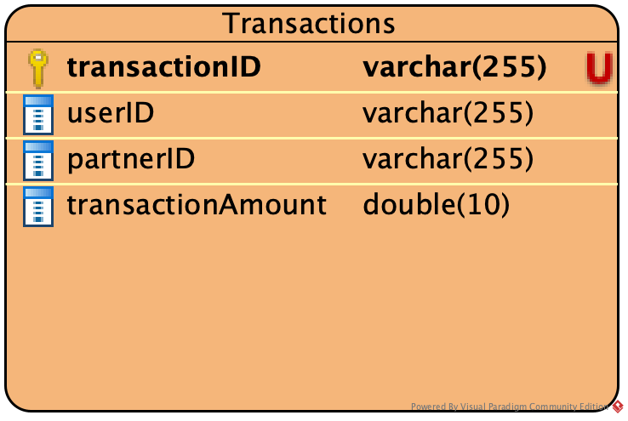
Fields
- transactionID: varchar(string), unique, not nullable, primary key to identify each transaction.
- userID: varchar(string), not nullable, links the transaction with a user, if project progresses beyond MVP, will be a foreign key
- partnerID: varchar(string), not nullable, links the transaction with a partner, if project progresses beyond MVP, will be a foreign key
- transactionAmount: double(10), not nullable, defines a cost per transaction

Implementation
First, we created an appropriate organisation and project on supabase, followed by creating our table:
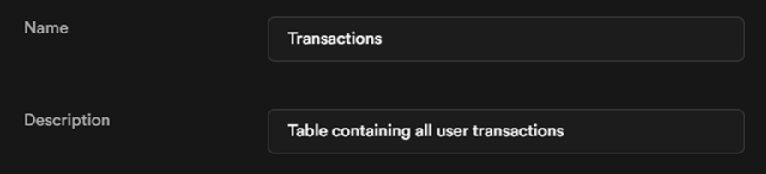
In the table we put the fields we planned during the design of the database, following the types and restrictions we planned:
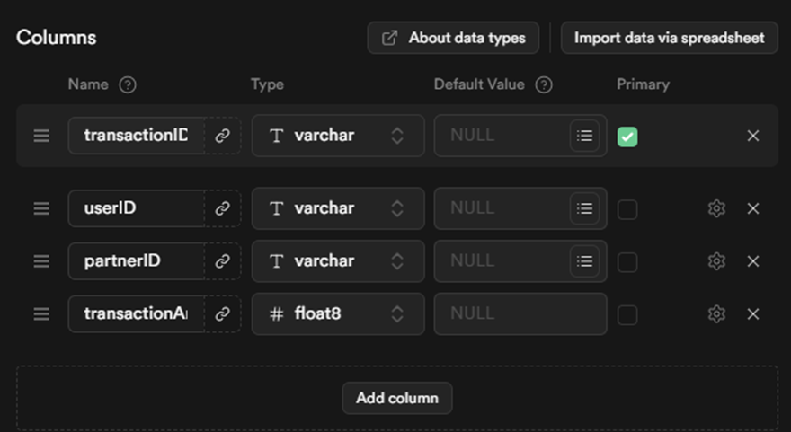
As the project MVP does not require a full authentication system, we made this table allow anonymous access, so that data can be written and wrote to it without using the supabase authentication system:
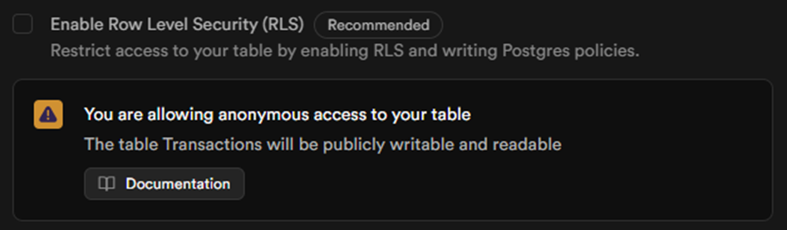
We then populated the table with some very basic data, with the TransactionID being a randomly generated UID:
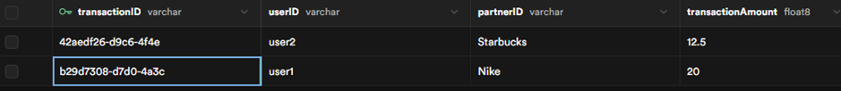
We also established a cron job to ping the database in order to keep it running.

Use of version control
Over the course of the project so far we have ensured consistent version control. Initially we branched off of main to create a dev branch. Main contains only the stable, production ready code and must not be pushed to, while dev contains development code.
All other branches root from dev, their branch names are of a consistent format: feature/<feature name> for branches that introduce new features, test/<test name> for branches that introduce tests, and issue/issue_<id> for branches that fix identified bugs. Before merging into main we will branch for release/version-<num>.<num>.<num> to conduct final testing. Only when a merge request has been reviewed by another member of the team may it be merged.
We have created a set of git commit guidelines that ensure commit messages are concise but descriptive. All commit messages are in the imperative mood so that they better describe what changes they apply, with commits that fix issues including their corresponding issue numbers e.g. Fix login error #22. (More guidelines and repository details can be found on the README on the dev branch)
We have also created a set of labels that we assign to each merge request to categorise what it introduces. Each merge request is also assigned either a frontend or backend MVP milestone.

Frontend MVP Milestone | Backend MVP Milestone
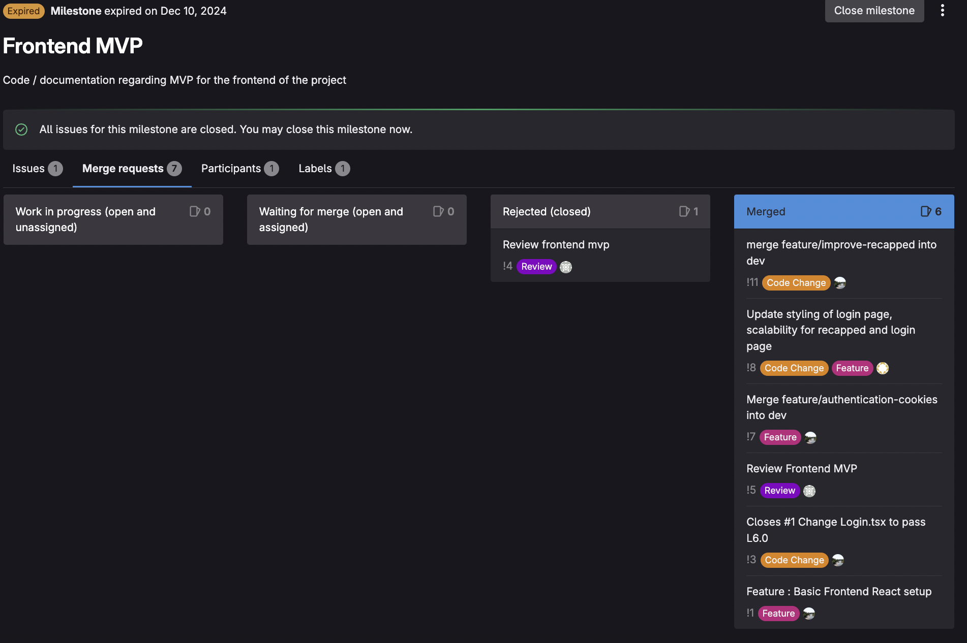 | 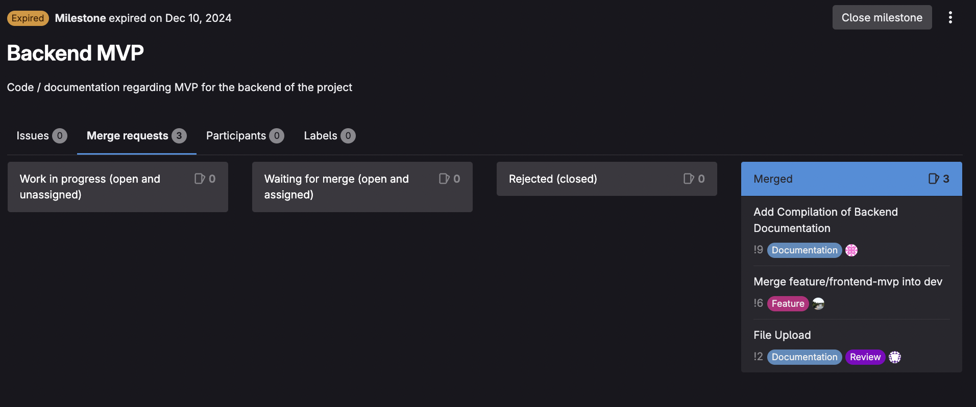
Branch Labels | Use of Branching
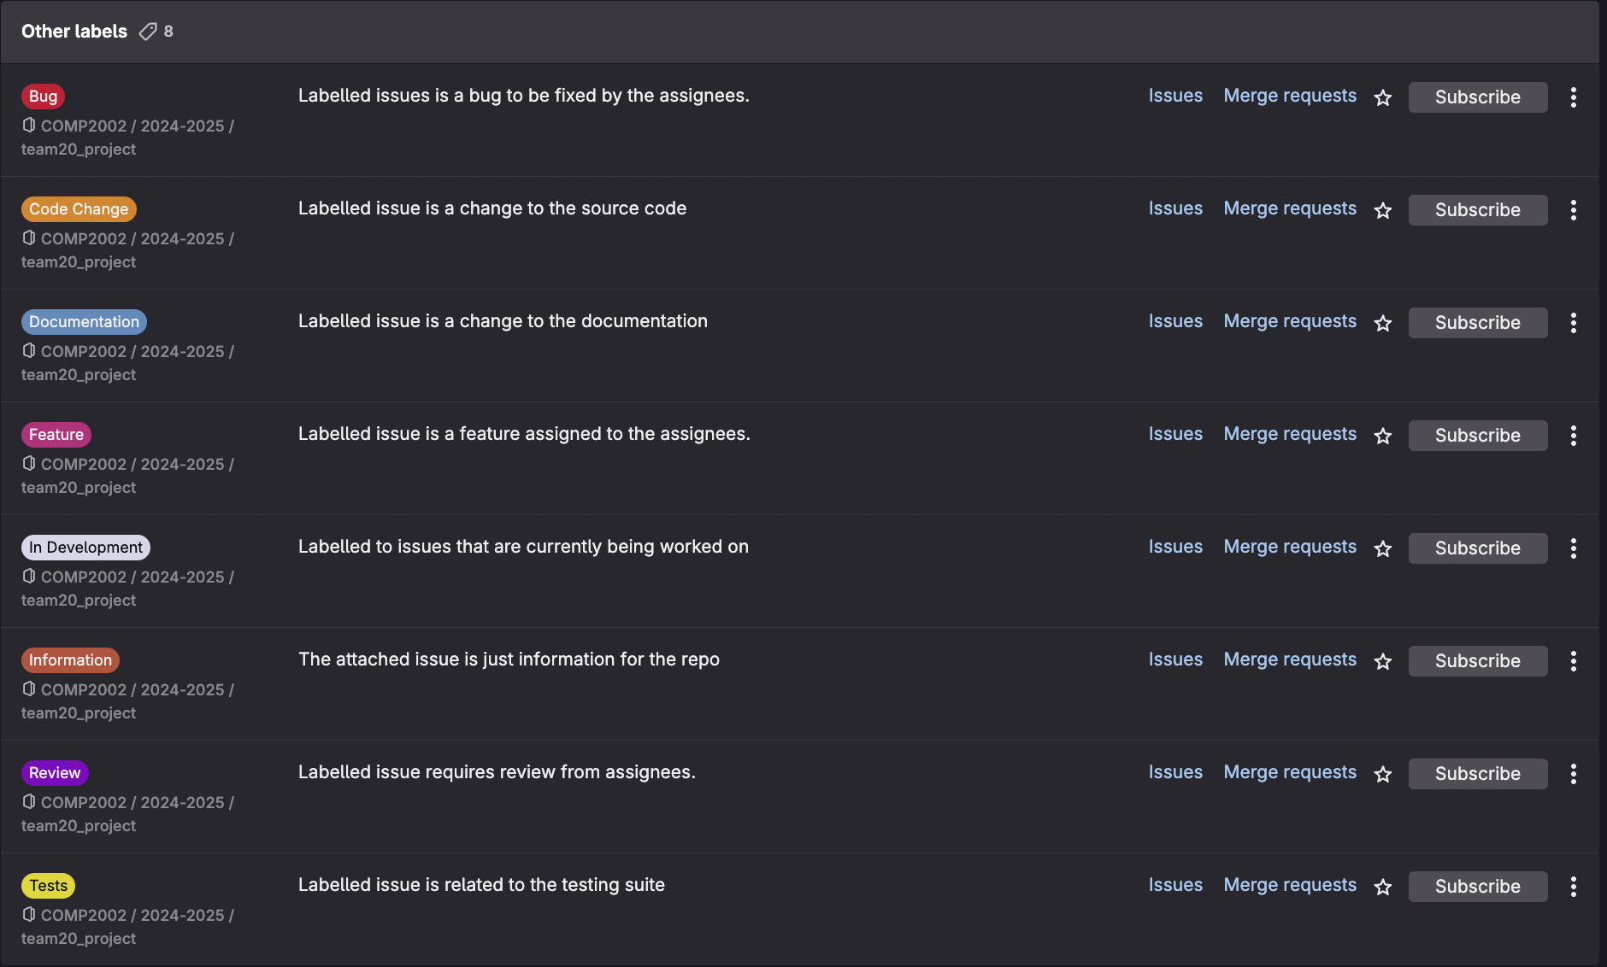 | 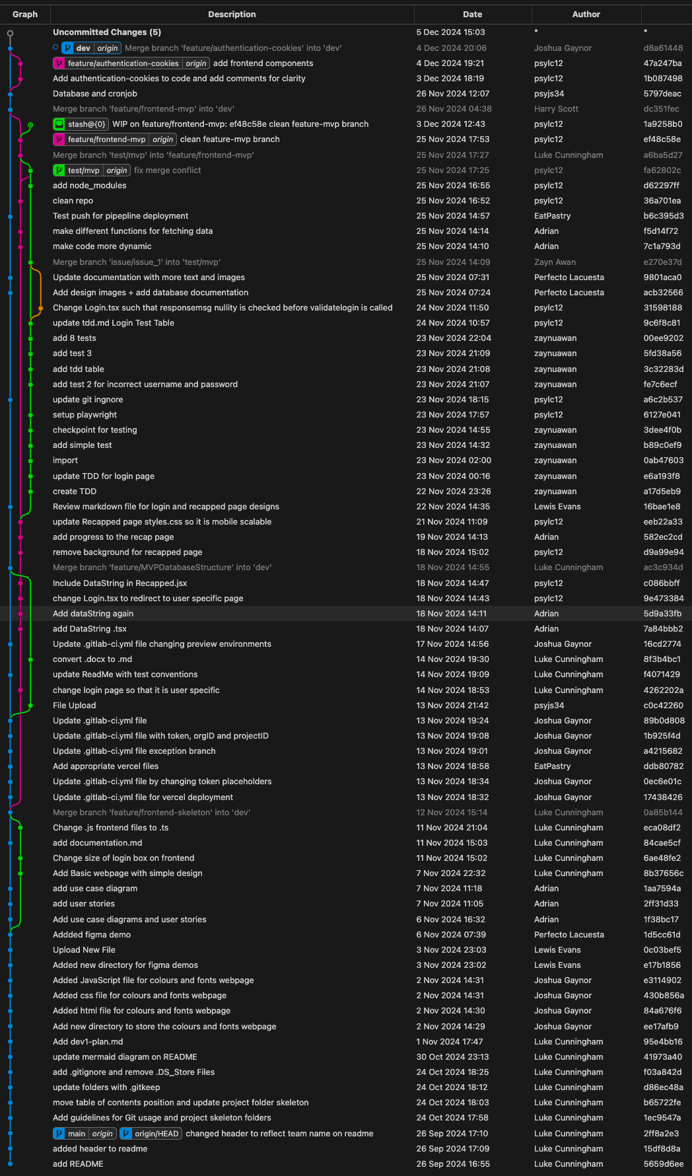

Comments
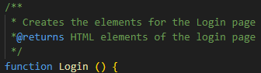
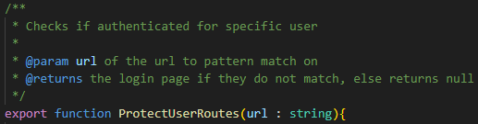
We have used JSDoc comments for detailed descriptions of the functions in our code, their parameters, and what they return. (see images below)

Evidence of testing
Below is a table of tests that were written for an earlier implementation of the project.
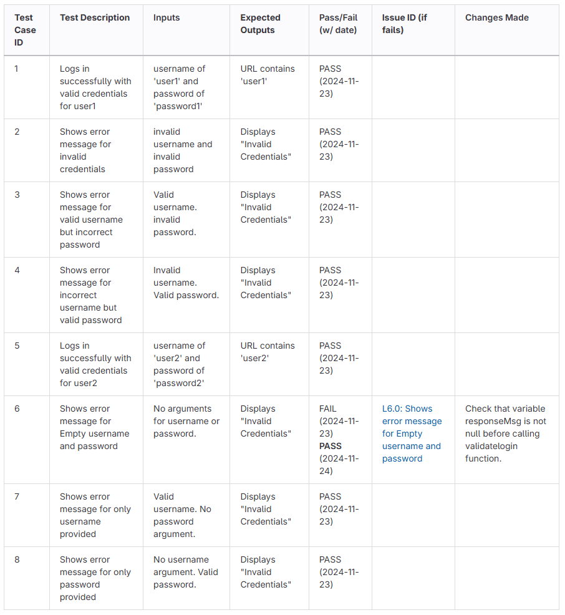
As the project is a web application, we used playwright, a library for Javascript which allows developers to script interactions with the website and test functionality. Here are some code snippets:
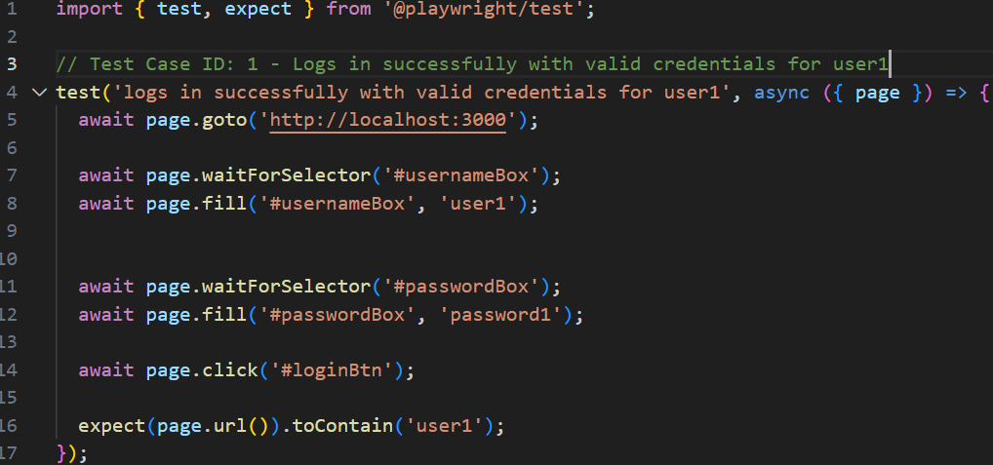 | 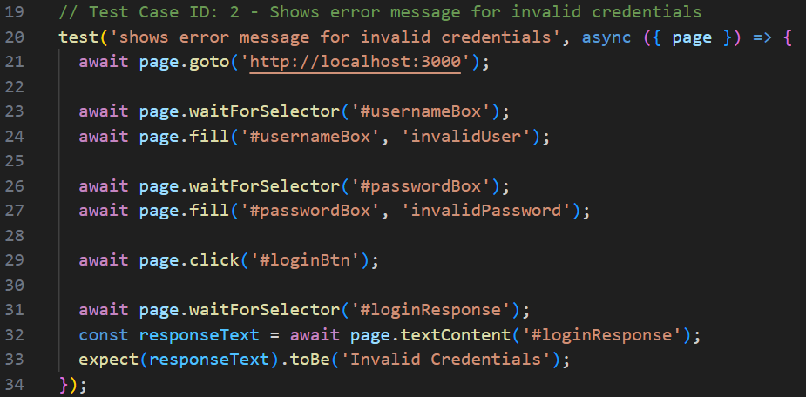

4.0 Project Management and Progress

4.1 Project Management Plan
As a team, we aimed to prioritize three main values: collaboration, transparency and adaptability. We believed following a 2-week sprint implementation of Scrum would allow us to effectively achieve frequent deliverables and releases, while adhering closely to our values.
After identifying that each main sprint should be broken down into three key stages: pre-production/planning, implementation, and a reflection period, we came up with the following meeting structure.
- A sprint planning meeting – early on in the first week; to divide up work from the product backlog and divide issues into a way that encourages collaboration.
- Standup meetings – Two per week at regular intervals during the first and second weeks; to monitor progress and discuss any immediate roadblocks.
- A sprint retrospective meeting – at the end of the sprint; to look at our progress in a wider context and share ideas for improving our approach going forward.
- A demonstration meeting – at the end of the sprint; to share and celebrate the progress we have made, as well as give UNiDAYS an opportunity to ask any questions and ensure that we are on the same page.
This structure is a slightly customized implementation of Scrum, crafted to meet our needs and requirements based on the amount of time we can commit to the group project.

4.2 Documentation of Sprints and Meetings
So far in the project, sprints have been documented using Trello, and each meeting has been documented via meeting minutes. These minutes were shared in an open channel on the group Teams, to ensure absent team members could catch up on project developments. Some examples of meeting minutes can be shown below:
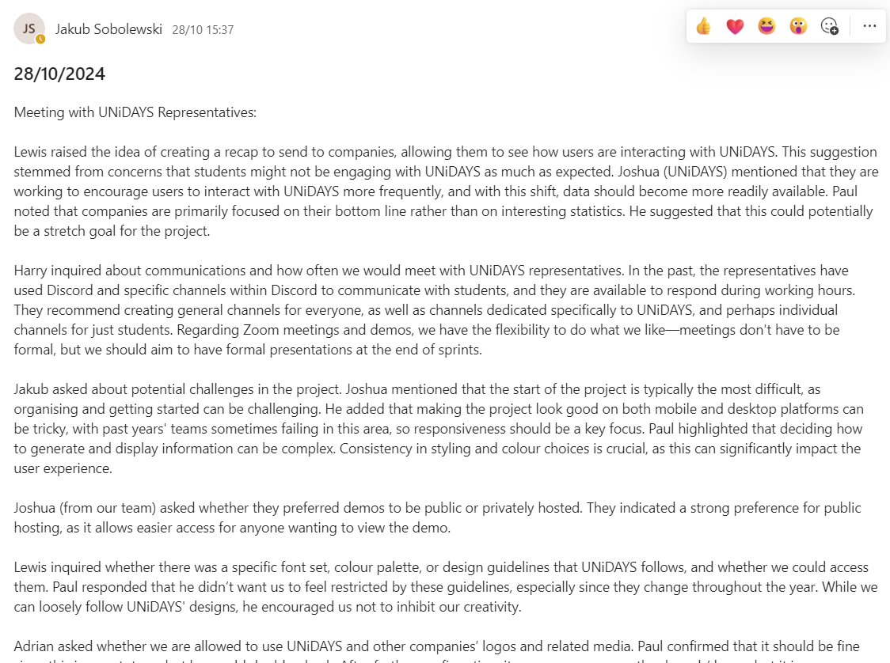 | 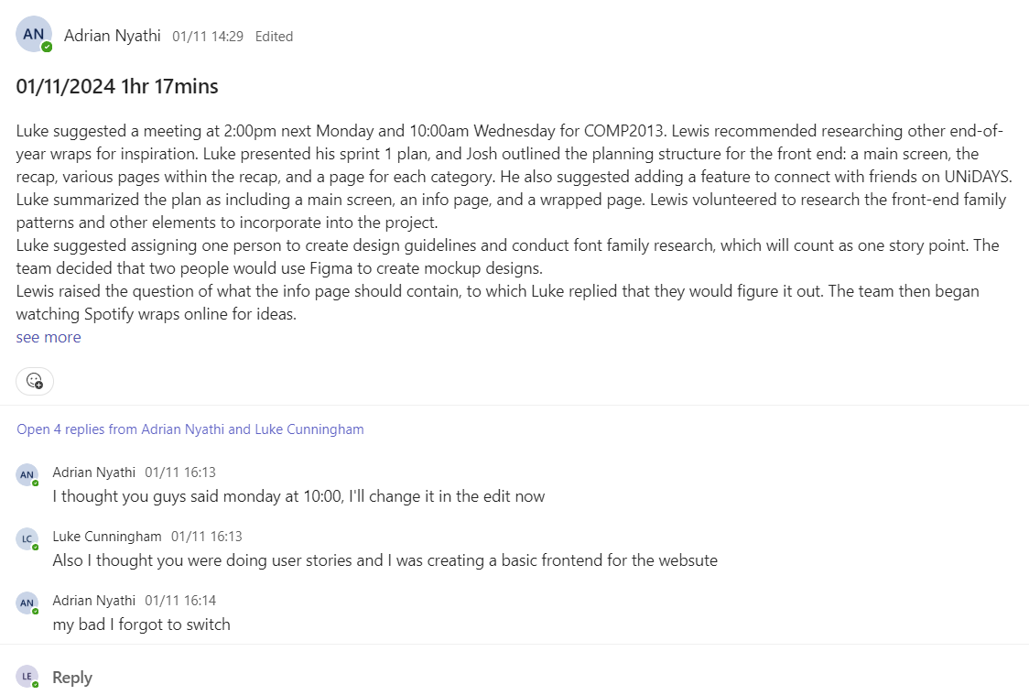

4.3 Use of Project Management Tools
For project management, we regularly use Teams for communications to schedule and hold meetings, progress updates and discussions about current problems. We also use Trello to define tasks and their assignees for each sprint. We have five sections on the Trello board: Backlog (Used to store templates for each card), To Do (cards that haven’t been started), In Process, In Review and Done. Usually, a different team member is assigned to review the card than the original assignee; this is for quality assurance. We also use a story point extension to denote the complexity of each cards’ implementation. This is on a scale of 1-3. Additionally, we use Discord to communicate, ask questions and schedule meetings with our industry supervisors, but we hold the meetings with them on Teams and in person.

4.4 Use of team skills and attitude
We all have experience with working in a team from last year's module along with additional experiences a few of us have had. As a team, we have communicated proficiently in both meetings and teams channels, and we practice active listening constantly, allowing all members to be heard and reflected upon. Collaboration is key, which is a strong skill we have as a team as, for example, when implementing new features that involve multiple members, we are constantly notifying one another of changes and questions, so that sustainable progress can be made.
We all have a positive, can-do attitude, with all work within a sprint being completed by its deadline consistently. Team meetings are held with no exceptions, with attendees being punctual, and meeting minutes being made for those who couldn’t attend. Although our sprints have tasks that are assigned to members, we also self-organize, so that if a task has been discovered after a sprint meeting, the member will use their initiative to complete the work.

5.0 Preliminary Reflection

5.1 Tools, techniques, methods, technical difficulties, testing
For tools we used git as our version control and used Trello to manage the workflow in a kanban like style. To host our database we used Supabase.We employed React with typescript and HTML,CSS for our frontend code and used the Playwright framework to test it. Joshua had encountered a problem in setting up Vercel(a platform to host websites which allows continuous deployment). The issue was that the git platform we use is privately hosted by the university. This meant git couldn’t simply be connected to the Vercel project. To solve this we have a pipeline which deploys to Vercel through a runner which is hosted on one of our machines using Docker.

5.2 Current progress and mitigation
Currently, we have developed the MVP (Minimum viable product), which includes login functionality and viewing the recapped page which uses a database to retrieve data depending on the user logged in. This is what we had intended to complete up to this point. The project has been managed well, with our start of sprint meetings clearly laying out what we need to achieve within the sprint and allocating the tasks, along with team voting for how many story points to give to each task. A problem we encountered initially was working out how to break down a sprint into tasks that could be distributed across the whole team. We also had a problem with communication through individuals working on interdependent tasks.
An area that needs to be improved come next development cycle is our consistency of task completion throughout the sprint. As represented in the burndown chart below, after our sprint planning session there is an initial spike in terms of work done and Trello cards completed. After that spike, the work stagnates until the end of the sprint where members rush to get the work done before our retrospective meeting. To mitigate this it might help to decompose our Trello cards into smaller tasks. We could assign these Trello cards to be completed at intervals throughout the sprint such as before the next standup meeting.
A graph to show Trello card completion over the course of the last Sprint (sprint 3)
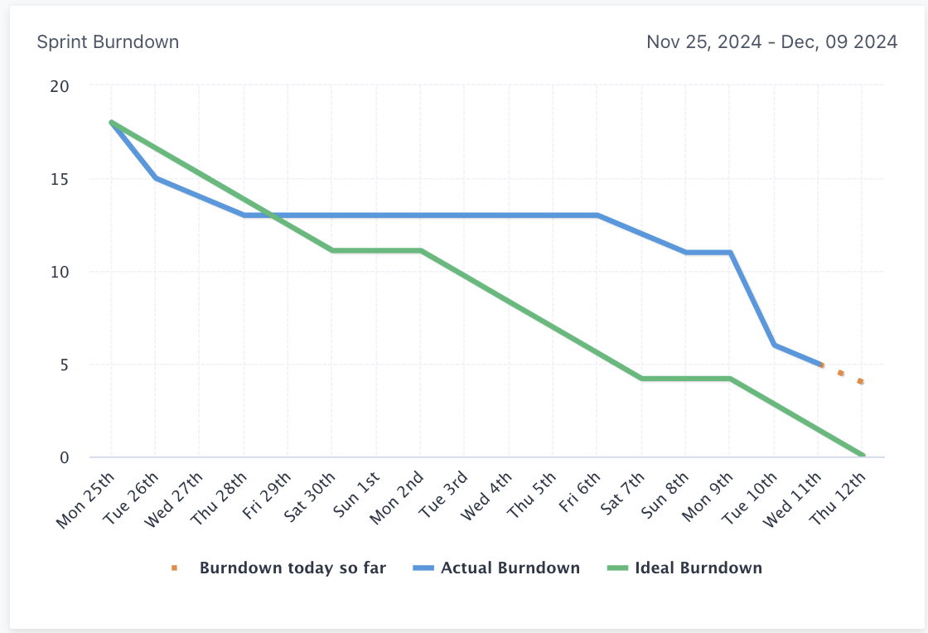

5.3 LSEPI

Intellectual property
Intellectual property such as our designs and source code belong to the team, but as we are only using it for this project, we will not be commercially exploiting or distributing the property; unless our stakeholders have a genuine interest in using our product.

Research ethics
When we conducted our survey, participants were volunteers and were asked non-compromising questions, simply asking for an opinion based rating on the appearance and usability of our web app.

Data protection
The project doesn’t collect or use any personal data, all data used is mockup.

Broader ethical and social considerations
The project will benefit students by helping them understand money saved from deals and discounts over the course of the year. This has no implication for criminal use. The project however, may have a slight social inequality bias, as those who spend more with UNiDAYS, save more. This might lead to a more grandiose Recapped over those who can't afford to spend more. This sense of monetary discrepancy, combined with the ability to share Recapped to social media might lead some users to flaunt their wealth indirectly through Recapped. This may have a negative impact from wealth comparison.

5.4 Team Member Contribution
First Sprint
Perfecto and Lewis worked together to come up with the designs for the Login and Recapped pages on figma (section 3.0 frontend). Adrian came up with user stories and a use case diagram. Joshua researched and chose useful fonts and colours. Zayn worked on the Team 20 Manifesto, emphasising its values of collaboration, transparency and adaptability. Jakub worked on initial plans for the database implementation. Luke set up the structure for the git repository and added git guidelines.
Second sprint
Adrian implemented the Recapped Page based on the Recapped designs while Luke implemented the login page based on the Login designs (section 3.0 frontend). Perfecto and Jakub researched databases and then created the database design (section 3.0 backend). Zayn authored comprehensive playwright tests for the login page, ensuring functionality and reliability. Joshua set up the CI/CD pipeline to push to Vercel to host the website. Harry reviewed these tasks ensuring they met the acceptance criteria.
Third Sprint
Perfecto wrote functions to pull from the database to the Recapped page. Jakub created the Supabase database and set up a Cronjob. Adrian compiled the work done on the frontend into a single document. Zayn compiled the backend documentation detailing database structure, service comparisons and implementation steps. Joshua and Luke revised the design of the Login and Recapped pages. Harry conducted a survey. Luke also set up cookies for login authentication to prevent unauthorised access.

5.5 Forward plans to address concerns Identified
We have become more experienced with using Trello to break tasks for distribution across the team and communicating together as a team. In order to further improve these processes we contemplate using critical paths to help show team members who they should communicate with and also help in breaking down the tasks to stop time where people are waiting on others during the sprint,therefore making the process more efficient.

6.0 Conclusion & Summary
Throughout the report we detail the progress we made on our Recapped project. We created a working proof of concept inline with the requirements outlined by UNiDAYS and have laid the foundation for every section of the project to be built upon in the next development cycle. This was achieved by careful requirements analysis and iterative approaches to software implementation. We kept close communication with our UNiDAYS supervisors to ensure that we didn't stray from scope in the production of the minimum viable product.
Throughout development 1 we faced challenges every step of the way, such as configuring Vercel, but by utilizing our individual strengths we have collectively overcome these. Through the report we have reflected upon what went well during dev 1, and what could be improved. By continuing our agile methodology into development 2 with these additional improvements we are confident that we will produce a successful final product.

